Course 5 Key Value stores

- Essentially a massive, distributed hash map.
- Optimized strictly for two operations: GET(key) and PUT(key, value).
- The Value is opaque- the DB does not see or care what is stored(no filtering or queries based on it) Can be anything -> Json, text, Image
- The Key has to be unique, and it is immutable, for a key change you actually do a new insert
- O(1) Lookup performance on the key
- Cap Model -> AP
- Implements BASE consistency
- Linear and horizontal scaling
- For persistent stores: LSM Trees (Log-Structured Merge trees) for write-heavy loads
- B/B+ trees for older/more general DBs
- A hash table maps keys to values using a hash function, which converts the key into
- an index (or "bucket") in an array.
- In case of a collision, liked lists or open addressing is used to handle it
- LSM Steps for writing a new record:
  - Write ahead log -> used for durability
  - Insert into MemTable
  - When it is full -> Flush to SSTable (Stored String Table) On Disk
When doing a lookup
- First check the MemTable
- Check immutable MemTables
- Last check on disk in SSTables(using a bloom filter and binary search)
- Common use cases:
  - Caching Layer
  - Session Management
  - Rate Limiting
  - Feature toggles
- Replication Models:
  - Master Slave
  - Multi Master
- Sharding: Consitent Sharding-> do a even distribution of the keys, minimize data movement
- Choose the concurrency Control:
  - Optimistic concurrency: Concurrent ops are allowed, the you detect conflicts
  - Pessimistic: Lock on data on updates

- Write-Ahead Log (WAL): Append-only log of updates before applying them.
- Snapshots: Periodic dumps of in- memory state to disk (e.g., Redis RDB).
- For recovery; load last snapshot and execute the WAL
- Conflict Resolution on Dynamo DB
  - Last Write Wins (LWW): Based on timestamp.
  - Read Repair: Resolve conflicts during read.
  - Client-side merge: Application decides how to reconcile.
- AWS Dynamo
  - Supports Key-value & Document stores
  - Support for ACID transactions
- Partition Key (Hash Key): Determines the data's physical location (shard).
- Sort Key (Range Key - Optional):Defines the hierarchical order within that partition.
- All queries have to use the partition key
- Sort keys allows efficient queries
- Indexes: Allows the same data to be viewed and queried in multiple ways.
- LSI (Local sort index) -> Same Partition key as the table, diff sort key -> reads are strongly consistent
- GSI( Global…) Diff partition key(Sort key can be diff or same) -> reads are eventually consistent
- Provisioned VS On-Demand
  - Provisioned: certain cost
  - On Dem: can spike up based on load
- Best Practice: Design the table structure (PK, SK, GSIs) to satisfy all application queries with single, efficient lookups.
- Open Source KV solutions: Redis, Memcached, Riak KV, LevelDB, RocksDB, BadgerDB
- Commercial: Amazon DynamoDB, Azure CosmosDB, GoogleCloud Datastore/Firestore
- DynamoDB:
  - Uses the Composite Key (PK+ SK) for core lookups.
  - GSIs: Crucial for flexibility and satisfying secondary access patterns.
- Tables – Similar to other database systems, DynamoDB stores data in tables. A table is a
- collection of data.
- Items – Each table contains zero or more items. An item is a group of attributes that is
- uniquely identifiable among all of the other items.
- Attributes – Each item is composed of one or more attributes. An attribute is a fundamental
- data element, something that does not need to be broken down any further.
- Partition key and sort key – Referred to as a composite primary key
- Global secondary indexes (GSIs) are indexes that span the entire table, allowing queries across all partition keys.
- Local secondary indexes (LSIs) are indexes that have the same partition key as the base table but a different sort key.
- Each table in DynamoDB has a quota of 20 global secondary indexes (default quota) and 5 local secondary indexes.
- Optional feature that captures data modification events in DynamoDB tables. The data about these events appears in the stream in near-real time, and in the order that the events occurred.
- Stream records have a lifetime of 24 hours;
- API
  - Control plane
    - Used to create and manage tables
  - Data plane
    - Used for CRUD ops
  - DynamoDB Streams
  - Transactions

Course 6 Document DBs
- They are based on KV stores, but their values are accessible to the system(can filter on the doc values)
- Schemaless design-> documents can have any format, usually JSON or BSON (Binary Json), schema can keep evolving
- Support Complex and nested Data structures, arrays, sub-documents, links to other docs
- Selecting a complete document is often more efficient than performing joins.
- Horizontal scalability
- These DBs are normally used for caching and metadata
- Bson supports binary data(ofc) and date types, unlike Json
- BSON is faster and is used internally in document DBs for storage and retrieval. Faster to traverse(as the type and length info for each field is given, so they can be skipped) -> Docs can be skipped entirely(Null bytes to signal the end of an elem and doc)
- JSON is ubiquitous, but slower to traverse, as it needs to be parsed in entirety
- Mongo DB
  - Is a cross-platform, document-oriented database that offers high performance, high availability, and easy scalability.
  - A collection is a group of MongoDB docs (equiv to a table)
  - Doc is a set of KVs
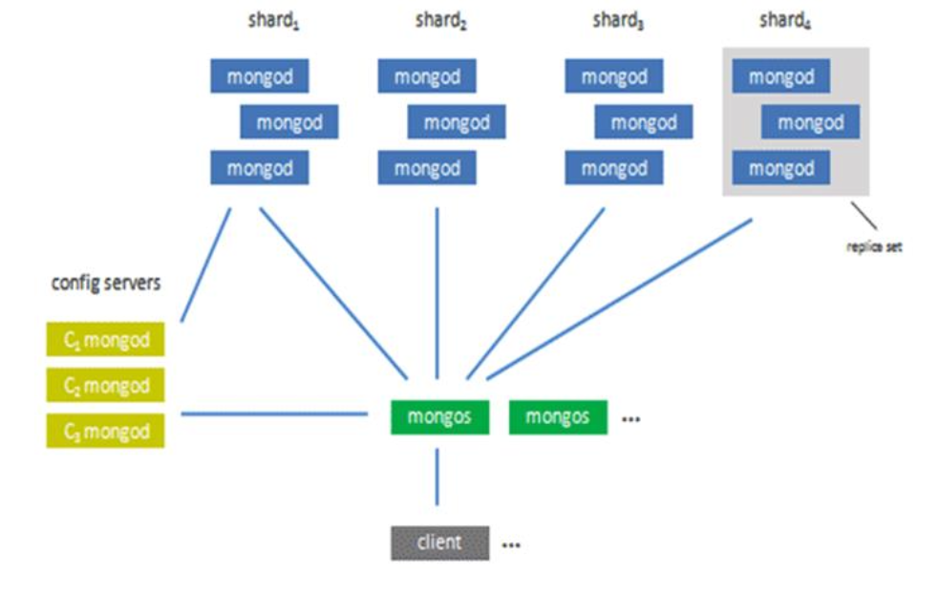
- Documents can store references (links to other docs), or nest other docs inside
- _id
  - is the primary key for every document in a MongoDB collection
  - it is unique, immutable and does Mongo does auto indexing of them
- Is a 12-byte BSON value that is typically represented as a 24-character hexadecimal string
- Mongo DB Indexes
  - Single Field and Compound
  - Multikey (arrays)
  - Geospatial
  - Text Indexes
  - Hashed Indexes
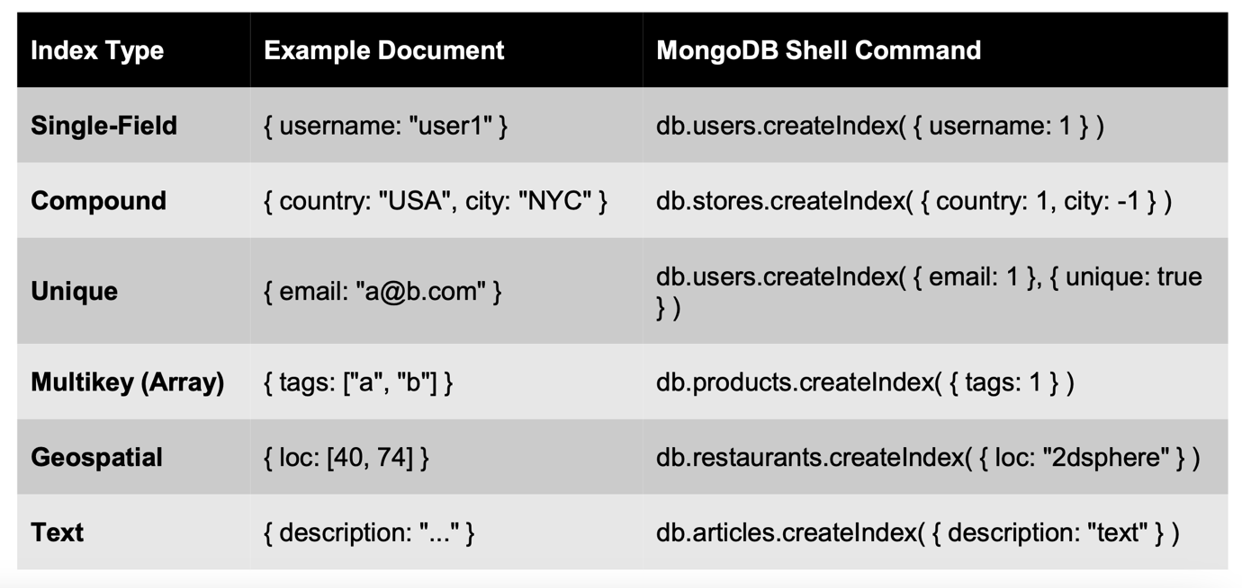
- Queries in MongoDB are performed using the MongoDB Query Language (MQL) and involve specifying conditions to retrieve documents from collections based on certain criteria. MongoDB provides a rich set of query operators and methods for filtering, sorting, and projecting data.
- Write Queries: A denormalized data model with embedded data facilitates atomic write operations, since a single write operation can insert or update the data for an entity
- Write operations with a weak write concern execute quickly. In some failure cases, write operations initiated with a weak write concern may not be persistent.
- With a stronger write concern, the client application must wait longer for the confirmation of write operations.
- Write Concern types:
  - Unacknowledged -> write with no confirmation
  - Acknowledged -> receive conf for data save
  - Journaled -> Receive receipt after the op was written to Log
  - Replica acknowledged -> Receive feedback only after op is propagated to replicas

- Aggregation operations process multiple documents and return computed results.
- An aggregation pipeline consists of one or more stages for processing documents:

For more explanation images you can have a look at the course slides (mostly for the Write Concerns and queries -> get an idea of the query structure

